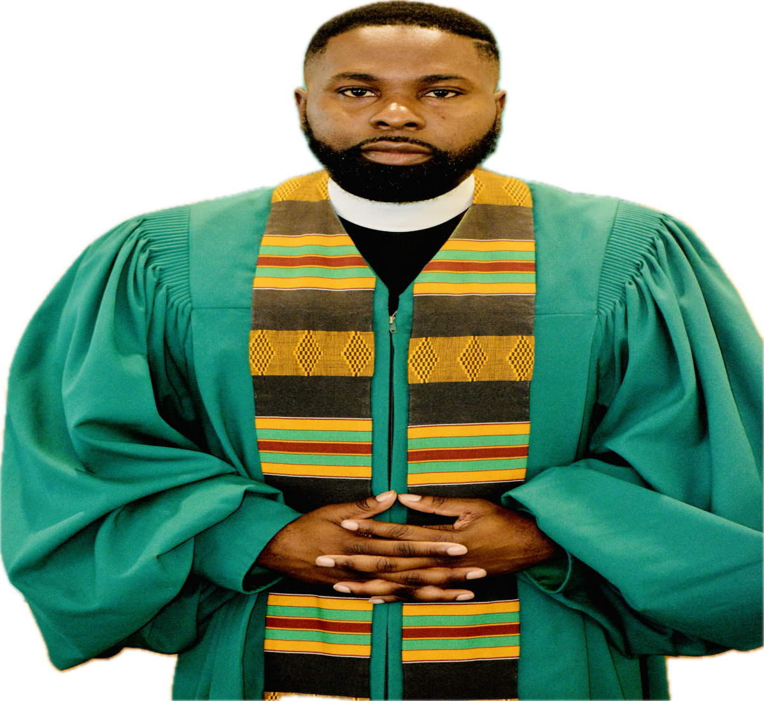
Rev. Pryce J. Battle, Sr. a native of Pittvsiew, Alabama, the youngest child of Ms. Shirley Battle and the late Deacon Earkus Battle. He currently serves as the Pastor of the Good Hope Missionary Baptist Church of Phenix City, Alabama and Moderator of the East Alabama Missionary Baptist Progressive Association, Inc. Rev. Battle is a member of the Mt. Mariah Missionary Baptist Church in Pittsview, Alabama Rev. Frederick Miller, Pastor
After accepting the call of Jesus Christ to the Ministry of Christianity on March 31, 2007, Rev. Battle was licensed and ordained by Pastor Solomon Tarver, Sr. and the Old St. John Missionary Baptist Church in Union Springs, Alabama. In 2010, Pastor Battle graduated from Russell County High School in Seale, Alabama. He pursued a higher level of education by attending Chattahoochee Valley Community College (2010-2012) Rev. Battle graduated from Troy State University in October 2021, earning a Bachelor of Science Degree in Interdisciplinary Studies (Education, Communication, S.T.E.AM Science, Technology, Art, and Math). The following January, Rev. Battle enrolled at Beulah Heights University, pursuing an M. Div with concentrations in Chaplaincy.
He was formerly employed by Russell County School System, Kysor Warren, and Lee County Youth Detention Center. He is also a member of Kappa Alpha Psi Fraternity, Inc. One of his most significant beliefs is that education is the key to success, but it takes faith to unlock every door. He has served in the workplace, community, and church with faith in God.
Rev. Battle is married to Mrs. Vanessa Battle. They are the proud parents of Pryce Jr., & Seriniti. However, out of all his success, accomplishments, accolades, and education, the most important one is that Rev. Pryce J. Battle, Sr. is a servant of God.
MINISTRY EXPERIENCE
- Pastor of Good Hope Missionary Baptist Church Phenix City, AL (2019-Present)
- Moderator of East Alabama Missionary Baptist Progressive Association, Inc. (2023-Present)
- Moderator of Friendship Missionary Baptist Association (2015-2019)
- Pastor of First Missionary Baptist Church Georgetown, GA (2013-2019)
- Pastor of Beulah Missionary Baptist Church Union Springs, AL (2011-2013)
- Youth Director of Old Pine Grove District Union Springs, Alabama (2008-2013)
- Assistant Pastor Old St. John Missionary Baptist Church Union Springs, AL (2008-2013)
- Pastor’s Alternative for Teacher Certification (2017) (through East Alabama Missionary Baptist Progressive Association)
- Registered Program Participant in the; Third District State Convention Georgia Baptist Convention (2013-2019), General Missionary Baptist Convention of Georgia (2013-2019), Southeast District State Convention of Alabama Baptist (2008-2013,2019-Present), Alabama State Missionary Baptist Convention (2008-2013,2019-Present), National Baptist Congress of Christian Education (2008-Present), National Baptist Convention USA, Inc. (2008-Present)
- Host Pastor, Southeast District State Convention Board (2025)
- Assistant Director (2023-Present) Southeast District State Convention Christian Edu.
- Staff Member (2023-Present) Southeast District, Alabama State, & National Baptist Convention’s Youth Young & Adult’s
- Copp Instructor (Certified; District, State, National)
- Bible Teacher
- Musician

